
I have created a St. Coletta team so you can register yourself under that or go in as individual!!!

- Go to www.finallegwi.org

- Scroll down and select Register Now!

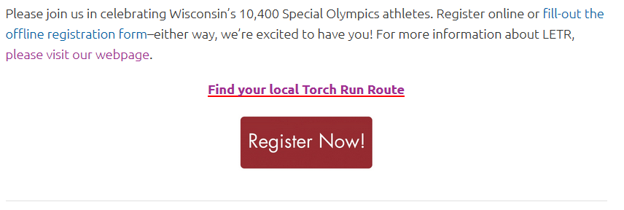

- Select Register for Final Leg (you can also donate to someone if you are not interested in participating!)
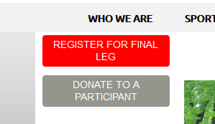
- Select Region 7 and click NEXT on bottom R page

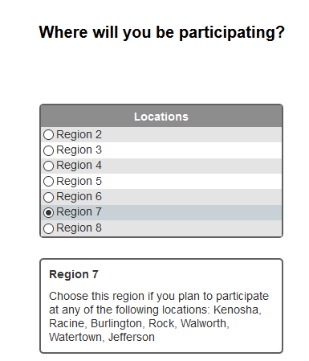

- This page will be the Waiver: Please review for yourself or the individual you are signing up and then select that you accept the waiver. Click NEXT after


- Select how you would like to participate Join St. Coletta’s or join as an individual (I will show you the steps to join STC’s team)


- Select Individual Participant- Raise $25 (you do NOT have to raise $25, but are more than welcome to) and then you can search under Team Name (St. Coletta) or Team Captain’s First Name (Stephanie) or Last Name (McDonald) You will then select the team to join in the dotted box Click NEXT
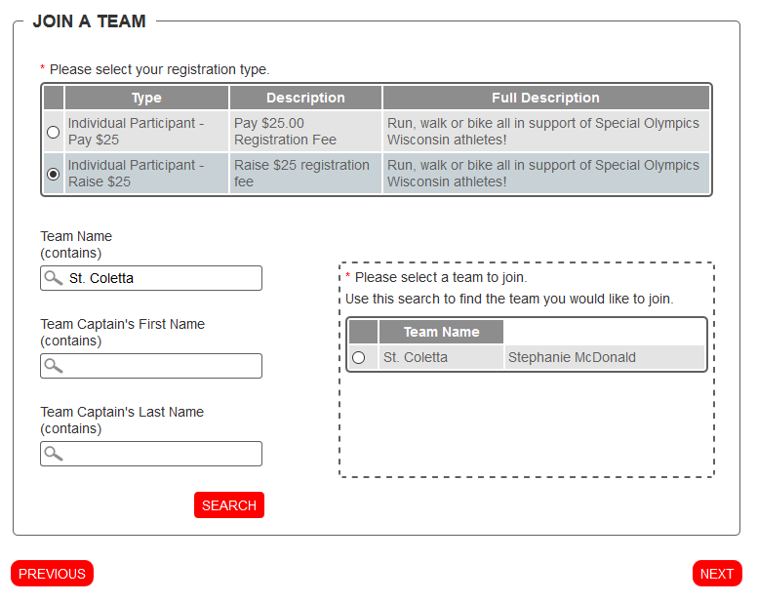

- Fill in the information needed: Name, Address, Account info (this will give you a link to send to friends and family for donations and allow you to sign into the site Continue with the rest of the registration. I have no more pictures to show since I have already registered…Here is what your Page will look like
